Safety Development Plan

Project Short Description: | MVC - SerDes Driver Qualification
Document author: | Heba Safwat
Document Responsibility: | Heba Safwat
Document Version: | 0.1
Document Classification: | Confidential
Document Status (Draft | Final): | Draft
Document Archive:

Document Revision History

Revision No. | Revision Date | Author | Description
0.1 | 15/06/2026 | Heba Safwat | Initial Version

Table of Contents
1. INTRODUCTION 4
1.1. Purpose 4
1.2. Project scope 4
1.2.1. Safety Project Scope 4
1.2.2. Work Breakdown Structure 5
1.3. References 5
1.4. Information Security Management 6
1.5. Quality Management 6
1.6. Communications Management 6
1.7. Requirements Management 6
1.8. Change Management 7
1.9. Configuration Management 7
1.10. Documentation management 7
1.11. Limitations 7
2. PROJECT TIMELINE 7
3. SAFETY PROJECT ORGANIZATION 8
3.1. Project Roles and Responsibilities 8
3.1.1. Project Management (PM) 8
3.1.2. Global Functional Safety Manager (GFSM) 8
3.1.3. Project Functional Safety Manager (PFSM) 8
3.1.4. Software Safety Engineer (SW_SAF_ENG) 8
3.2. Assigned Resources 9
3.3. Resources Competency 9
4. PLANNED SAFETY ACTIVITIES AND DELIVERABLES 9
4.1. Management of Functional Safety 9
4.1.1. Safety Development Plan 10
4.1.2. Safety Case 10
4.1.3. Confirmation Measures 10
4.1.4. SW Component Qualification Report 10
4.1.5. SW Component Qualification Verification Report 11
4.1.6. SW Tools Confidence 11
4.2. SW Component Qualification 11
4.2.1. SW Safety Analysis 11
4.2.2. SW Safety Requirements 11
4.2.3. Static Analysis Report 11
4.2.4. Test Plan 12
4.2.5. Test Report 12
Tables
Table 1: Project Information 4
Table 2: References 6
Table 3: Assigned Resources 9
Table 4: FuSa management activities and deliverables 10
Table 5: Planned Confirmation Measures 10
Table 6: Methods for deriving test cases for software unit testing 12
Table 7: Structural coverage metrics at the software unit level 12
Figures
Figure 1: Planned Safety Activities 5

Abbreviations
Explanation of used abbreviations.

Abbreviation | Explanation
BSS | Brightskies
SP | Safety Plan
WBS | Work Breakdown Structure
PM | Project Manager
TCL | Tool Confidence Level
CDD | Component Design Document
GFSM | Global Functional Safety Manager
PFSM | Project Functional Safety Manager
SW_SAF_ENG | Software Safety Engineer
SW_DEV_ENG | Software Development Engineer
SerDes | Serializer/Deserializer

INTRODUCTION
The safety development plan (SP, this document) is the main planning document for functional safety. It identifies and describes all functional safety activities which are planned to be carried
out for the project during the safety lifecycle of the software component under qualification. The ultimate goal of the safety development plan is to compile the component safety case that communicates a clear, comprehensive, and defensible argument that
(1) The software component qualified by the development activities have been analyzed and tested
(2) The risks to human beings associated with operation of the component in an automotive vehicle is at an acceptable level.

Purpose
This SP mainly describes functional safety project specific items:
- Objectives to reach (as defined with the customer during elicitation phase),
- Project description,
- Project team description,
- Project Activities,
- Applicable documents to the project,
- Project schedule,
- Project deliverables.
And to ensure that all requirements of ISO 26262-8:2018 clause 12 with respect to safety development plan generation are addressed:
- Safety project organization
- Planned safety activities
- Planned work productsProject scope

Project scope

Safety Project Scope
The SerDes driver subject of this safety development plan allows applications to use the provided API to configure serializer/deserializer chips to communicate with host ECU. The files provided for the driver qualification include code files and header files.
Brightskies will be responsible for activities and deliverables required for the qualification of SerDes driver to ASIL B component in compliance with ISO 26262-8:2018 clause 12.

Project Information
Project ID | BSS_FS_SQ_001
Project Name | SerDes Driver Qualification
Customer | Mekra Lang
Initial Project schedule
Start Date/Week of the Project | CW12 of 2026
End Date/Week of the Project | CW31 of 2026
Table 1: Project Information

Work Breakdown Structure
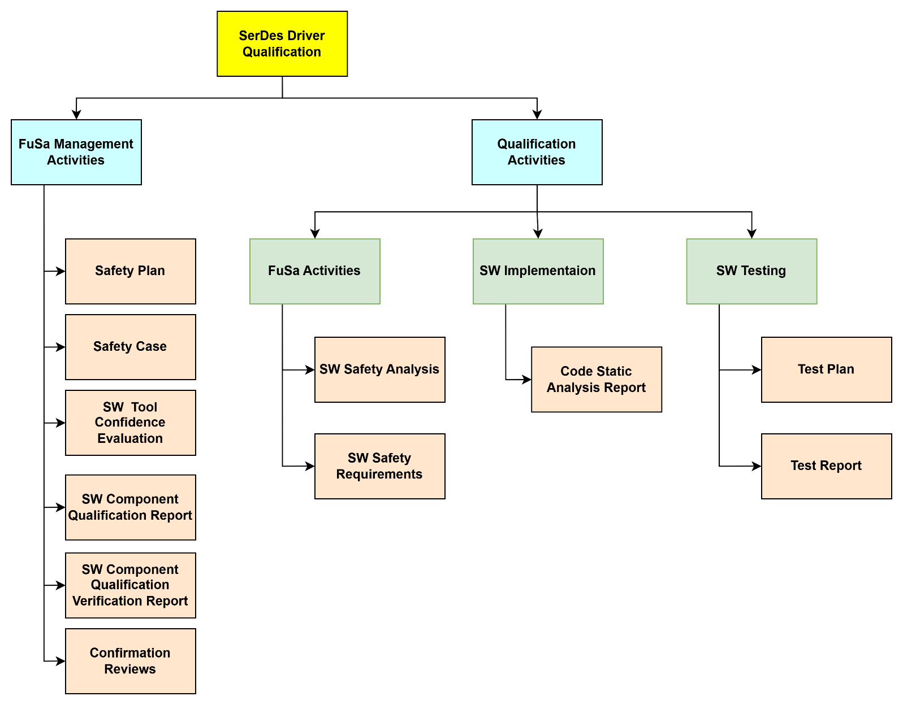
The WBS shown in the following figure explained in details at the Planned Safety Activities and Deliverables section.
Figure 1: Planned Safety Activities

References
The applicable standard documents for the project are:

Ref. | Filename | Description | Author | Version
Ref.1 | [ISO standard] | ISO 26262-8:2018 clause 12 ISO 26262-2:2018 clause 6  ISO 26262-6:2018 clause 9 | ISO | Second edition 2018
Ref.2 | [SerDes Driver SW] | SW code for configuring serializer/deserializer to achieve communication with host ECU | Ambarella | -
Ref.3 | [MISRA C] | MISRA C provides a set of rules and recommendations aimed at improving the reliability, safety, and maintainability of software written in the C programming language. | MIRA Limited | 2012
Ref.4 | [ISO 9001 Certificate] | Brightskies software solutions ISO 9001:2015 Certificate | ISO | 2015
Ref.5 | [TISAX Label] | Brightskies software solutions TISAX Label | ENX | -
Table 2: References

Information Security Management
The shared information and data transferred from and to the client shall be protected all the time. Only team members are given access to view the data that concerns their part of work to ensure the information security between Mekra Lang and BSS.
BSS has achieved TISAX label. It confirms that the company’s information security management system complies with defined security levels and allows sharing of assessment results across TISAX platform.
TISAX Label Data:
- Scope ID: SHX8YP
- Assessment ID: AKX8YP-1
- location IDs : LN3T6K & L58915
- Label validity : 14/09/2025

Quality Management
According to ISO-26262 the output work products shall go through reviews, assessments and confirmation measures according to the ASIL level of the component, although all work products shall be going through peer review and senior review to verify the quality of work products in BSS before the work products release to Blackberry QNX.
BSS has achieved the ISO 9001 quality management system certificate. It demonstrates the organization commitment to quality and continuous improvement.

Communications Management
A regular meeting shall be held between Mekra Lang and BSS to discuss the progress,
issues, risks, inquires and actions. Other meetings and calls including technical discussions shall be held in case of critical issues. Else it should be communicated by mail.
All changes in the scope of work shall be communicated by mail and through CRs and shall be approved by both sides.

Requirements Management
The requirement management process shall support:
- Requirements structure check;
- Traceability between requirement and test cases shall be stated.
To indicate the relevance of some requirements regarding functional safety, attributes with defined values shall be added.

Change Management
Any change in the scope of work held between Mekra Lang and BSS shall be requested by a change request (CR) in which both parties should agree to the new scope of work and the new estimated hours.

Configuration Management
The configuration management shall assure:
- Unique identification of the component;
- Version control for the component source code and related files;
- Qualification work products configuration management;
- Release management.
BSS will handle the component source code and required documents in the qualification process. Configuration management ensures smooth handling and better quality of the qualification process.

Documentation management
Following aspects must be applied to the project documents:
- The content of a document shall be structured in a clear manner (use of standard templates), precise and concise and maintainable.
- Formal aspects must be incorporated as defined by the used template, but shall at least provide the following information:
- Purpose, scope and context;
- Approval and modifications control.
- References.
- Abbreviations and definitions.
- Revisions and history.
- Revision number and status must be derived from configuration management.

Limitations
No significant limitations exist.

PROJECT TIMELINE

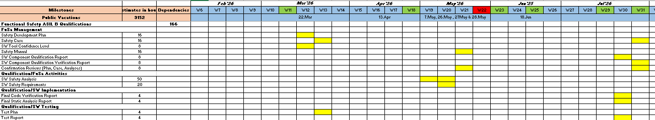

SAFETY PROJECT ORGANIZATION
The sections that follow provide information about the safety organization and project roles and responsibilities that are involved in that lifecycle. They also identify key competency areas assigned to specific roles of the safety lifecycle, including their expected contributions.

Project Roles and Responsibilities

Project Management (PM)
The PM is responsible for the planning, tracking, and performing adjustments, as appropriate, of functional safety activities. The PM responsibilities are:
- Ensuring the completion of the project activities and work products within the project time schedule;
- Ensuring that sufficient resources and tools are available in the project;
- Ensuring that safety related issues are communicated and action items are tracked;
- Ensuring that the safety activities are carried out as planned in the Safety Plan.

Global Functional Safety Manager (GFSM)
The global functional safety manager shall be the approver of the functional safety (FuSa) activities in the safety lifecycle. The GFSM responsibilities are:
- to approve all the project safety activities and work products;
- to ensure that all the work products meet the functional safety requirements of the project;
- to ensure the revision, approval and implementation of the safety plan;
- to plan and perform confirmation measures and reviews;
- to approve the tailored decisions in the project safety lifecycle according to the component ASIL in order to comply with ISO 26262:2018;
- to manage the certification process in the project;
- to provide consultation for the project management (PM) during the execution of functional safety activities.

Project Functional Safety Manager (PFSM)
The project functional safety manager is responsible of managing the project functional safety activities workflow and work products. The PFSM responsibilities are:
- to prepare the safety plan, component safety manual and safety case in the project;
- to ensure that all work products meet all functional safety requirements for this project;
- to manage the safety plan and track progress in the safety activities and work products for the duration of the project;
- to tailor decisions in the project safety lifecycle according to the component ASIL in order to comply with ISO 26262:2018;

Software Safety Engineer (SW_SAF_ENG)
The software safety engineer is responsible for developing and implementing safety mechanisms in the source code. The SW_SAF_ENG responsibilities are:
- Performing software safety analysis and deriving software safety requirements;
- Implementing software safety mechanisms after analysis;
- Checking of static analysis report;
- Checking of test report

Assigned Resources

Role Name | Role Description | Current Responsible | Contact
PM | Project Manager | Nada Tamer | nada.tamer@brightskiesinc.com
GFSM | Global Functional Safety Manager | Ahmed Abd El-latif | ahmed.abdellatif@brightskiesinc.com
PFSM | Project Functional Safety Manager | Mohamed Elbeih | mohamed.elbeih@brightskiesinc.com
SW_SAF_ENG_1 | SW Safety Engineer 1 | Heba Safwat | heba.safwat@brightskiesinc.com
Table 3: Assigned Resources

Resources Competency
BSS team working on the project demonstrates a high level of competency and expertise which ensures the quality of the qualification activities and work products. Their extensive knowledge, coupled with their problem-solving abilities, ensures effective and efficient execution of the qualification process.
Competency report will be prepared to provide evidence for the competencies possessed by the team which ensures the project execution with outstanding outcome.

PLANNED SAFETY ACTIVITIES AND DELIVERABLES
This section outlines the work products planned for the project following the ISO 26262:2018 standard as guidance. Tailoring of the processes is also presented as applicable
This section is divided into two major sub-sections as follows:
1. Management of functional safety 2. SW component qualification
Brightskies will be responsible for all the following activities and deliverables required for the qualification
of sensor driver to ASIL B component in compliance with ISO 26262-8:2018 clause 12

Management of Functional Safety
The FuSa management activities and deliverables will be executed and delivered according to the following timeline

Work Product | Delivery Date
Safety Development Plan | CW11 2026
Safety Case | CW13 2026
Confirmation Mesures | CW29 2026
SW Component Qualification Report | CW28 2026
SW Component Qualification Verification Report | CW29 2026
SW Tools Confidence | CW11 2026
Table 4: FuSa management activities and deliverables
The following is description for the planned FuSa management activities and deliverables:

Safety Development Plan
This document contains the safety development plan which defines all activities in the project safety life cycle in compliance with ISO26262:2018 Standard.

Safety Case
Safety case is the ultimate goal of developing a safety development plan which is required for ASIL rated systems.
The safety case should progressively compile the work products that are generated during the safety lifecycle. Safety Case will be packaged, reviewed and accepted by the customer and the responsible FSM.

Confirmation Measures
The confirmation measures include confirmation reviews, functional safety audits and functional safety assessments. The confirmation reviews are intended to check the compliance of selected work products to the corresponding requirements of ISO 26262:2018. Only confirmation reviews are planned for the scope of SW driver qualification.
Confirmation measures report shall be included in the Safety Case. Confirmation Measures will be executed for the work products in the below table.

Work Product | Degree of independency applied to  ASIL-B Components
Safety plan | I1
Safety Analyses (FMEA, FTA, etc.) | I1
Safety Case | I1
Table 5: Planned Confirmation Measures
Note:
I0: the confirmation measure should be performed;
I1: the confirmation measure shall be performed, by a different person
I2: the confirmation measure shall be performed, by a person from a different team
I3: the confirmation measure shall be performed, by a person from a different department or organization
Upon completion of a confirmation review, the work product may be
- Accepted without major corrections,
- Conditionally accepted,
- Rejected

SW Component Qualification Report
SW component qualification report documents the evaluation of the component for the suitability
of re-use in items or systems developed in compliance with ISO 26262:2018 according to the required ASIL level. The report shall contain SW architecture overview, qualification
criteria,….etc.

SW Component Qualification Verification Report
SW component qualification verification report documents the results of the component qualification together with the validity of these results regarding the intended use of the software component and the required ASIL level of the component in accordance to the ISO 26262:2018.

SW Tools Confidence
The used software tools in the component qualification process shall be ensured that its usage, its determined environmental and functional constraints and its general operating conditions comply with its evaluation criteria or its qualification in accordance to the ISO 26262:2018. The TCL shall be ensured to confirm that the ASIL level of safety requirements allocated to the qualified SW component will not be violated by the usage of the selected SW tools.

SW Component Qualification
The following section describe the sensor driver qualification activities and deliverables developed in compliance with ISO 26262-8:2018 clause 12,

Work Product | Delivery Date
SW Safety Analysis | CW17 2026
SW Safety Requirements | CW18 2026
Static Analysis Report | CW28 2026
Test Plan | CW13 2026
Test Report | CW28 2026

SW Safety Analysis
Software Failure Mode and Effects Analysis (FMEA) will be performed to systematically analyze potential failure modes and their effects on the functional safety of the component. It focuses on identifying and mitigating potential failures and risks associated with the components. It aims to ensure the sensor driver functions reliably and safely throughout its lifecycle.

SW Safety Requirements
SW safety requirements will be defined to address the safety mechanisms derived from the SW FMEA to mitigate the identified failure modes and reduce their impact on safety. It will address design changes, redundancy mechanisms, error handling procedures, or diagnostic strategies

Static Analysis Report
The sensor driver code static analysis report will be prepared to summarize the results of static analysis performed on the component after applying modifications derived from qualification activities in compliance with ISO 26262-8:2018 clause 12 (Ref. to Table 5: 1h in this document). It will summarize the final results of the static analysis performed to the component. PC-Lint tool will be used through the static analysis processes.

Test Plan
Test plan is the document which describes sensor driver unit testing areas and activities. It outlines the test strategy, objectives, test schedule, required resources (human resources and software), test estimation and test deliverables. It is the base of software testing process. It ensures the execution of the planned activities in an appropriate sequence. Only unit testing will be executed for the SW component.
Methods of deriving test cases and structural coverage metrics will be according to the required ASIL level of the component (ASIL B) in compliance with ISO 26262-8:2018 clause 12.
Methods of deriving test cases (Ref. to Table 6) will be analysis of requirements, generation and analysis of equivalence classes, and analysis of boundary values.
Structural coverage metrics which will be covered in the driven test cases (Ref. to Table 7) are statement coverage and branch coverage.

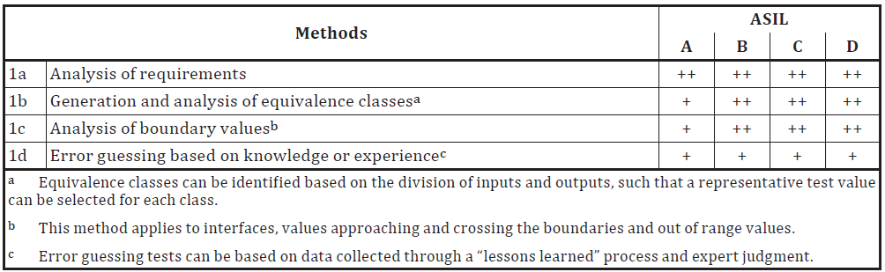
Table 6: Methods for deriving test cases for software unit testing

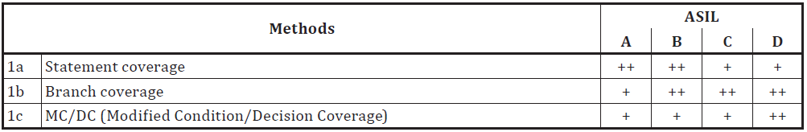
Table 7: Structural coverage metrics at the software unit level

Test Report
Test report is the document that provides an overview of the testing activities performed on the sensor driver. It documents the testing process and results obtained from the test execution.
This report will state the traceability relationship between requirements and test cases. Traceability ensures that each requirement is properly implemented, tested, and validated.

